**Project name: Restaurant Management System**

* **Introduction**
* It is a website that is designed on PHP and tested on cypress software that allows the user to book the table. All the links and designs are checked so automation test case is all about automating these functionalities. The main idea of this project is to create all the process into cypress.
* **Scope of the project**
* It enables the customers to quickly manage the online menu as well as it helps the users to easily place the order with just few clicks.
* Also it simplifies the order process for both customer and restaurant.
* This website presents an interactive and up-to-date menu with all available options in an easy to use manner.
* Even customer can choose one or more items to place an order which will land in the Cart and customer can view all the order details in the cart before checking out.
* At the end, customer gets order confirmation details. Once the order is placed it is entered in the database and retrieved in pretty much real time. This allows Restaurant employees to quickly go through the orders as they are received and process all orders efficiently and effectively with minimal delays and confusion.
* **Project screenshots**
* **Table booking form**

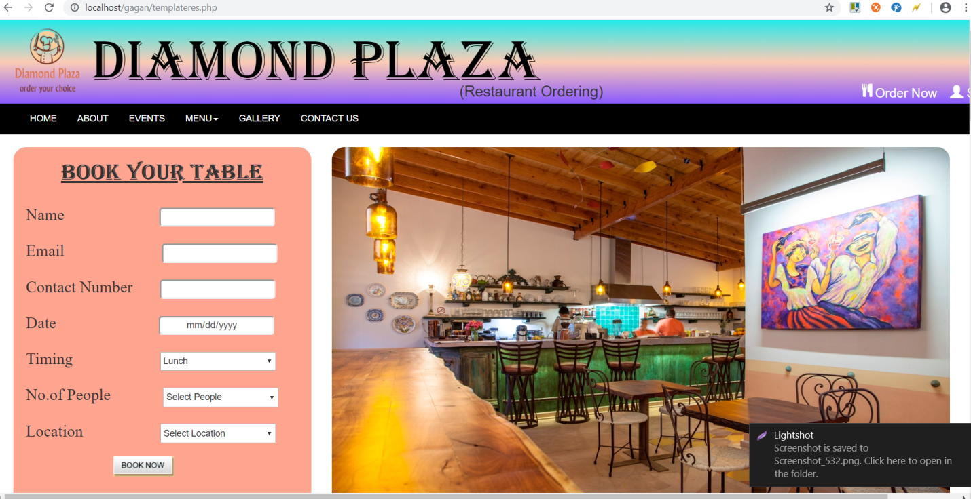

* **Home page**

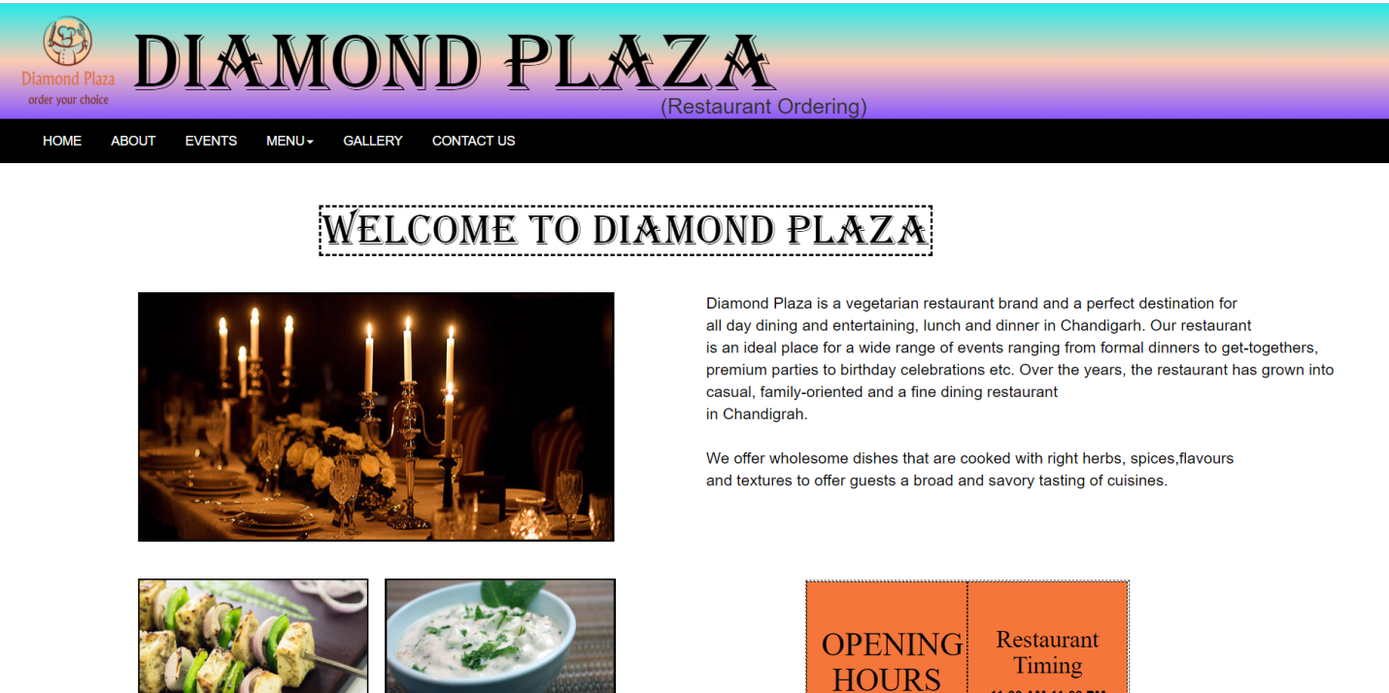

* **Gallery page**

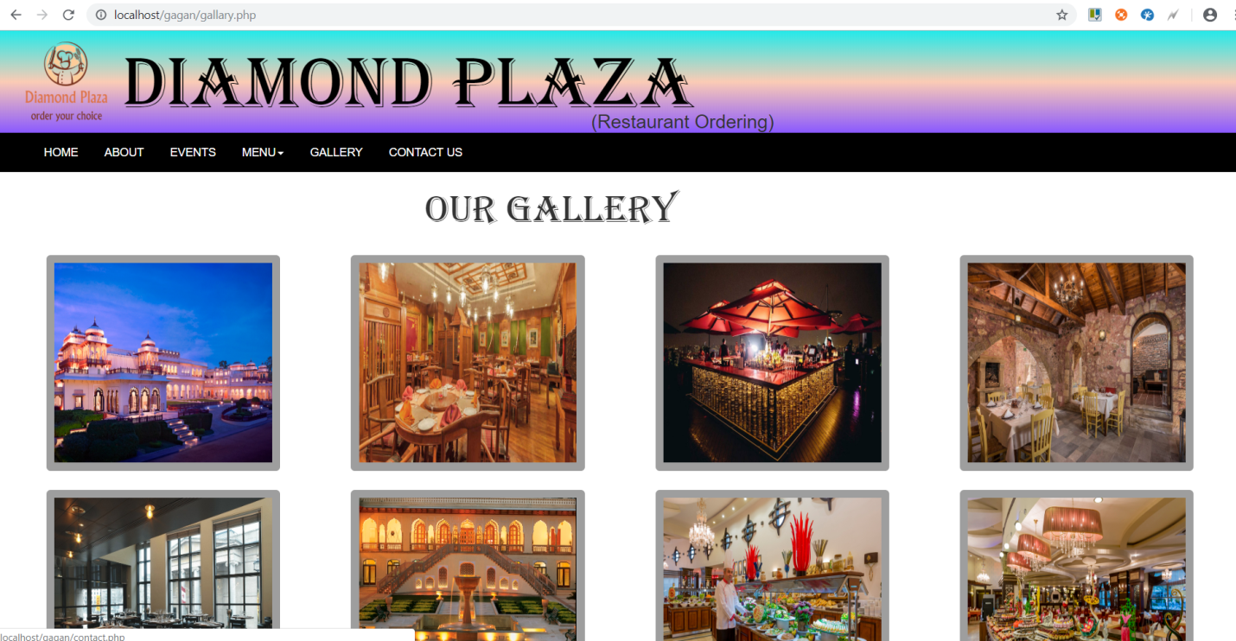

* **Test cases in cypress**

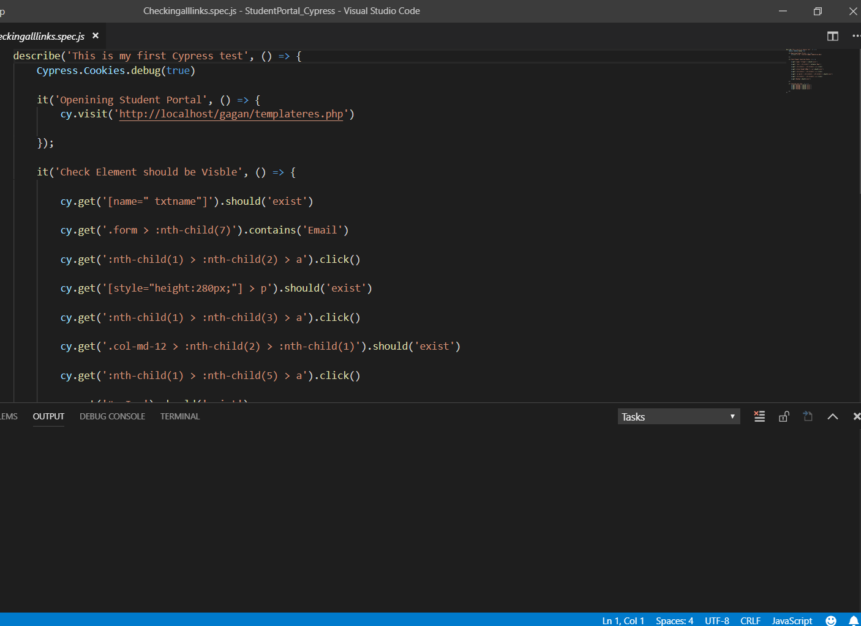

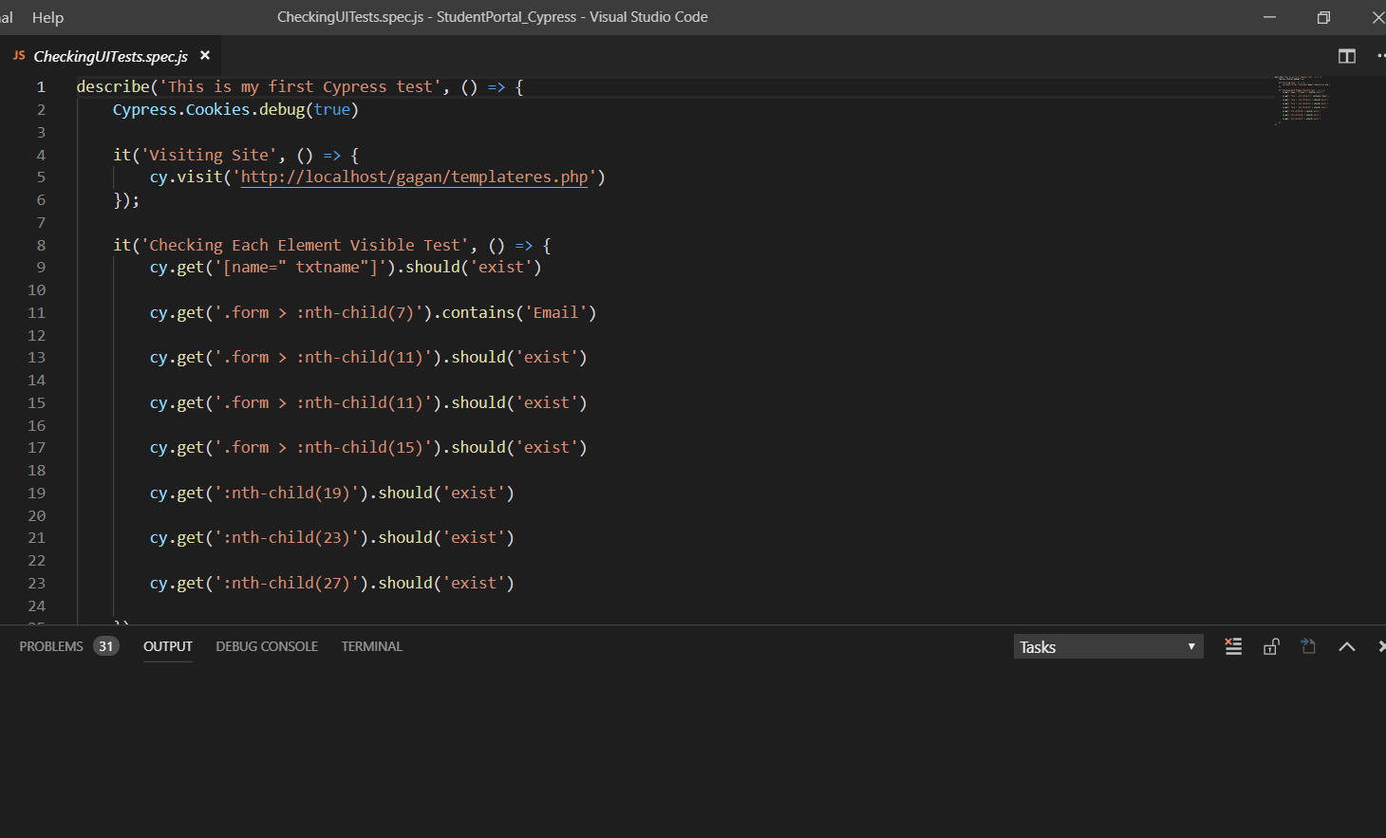

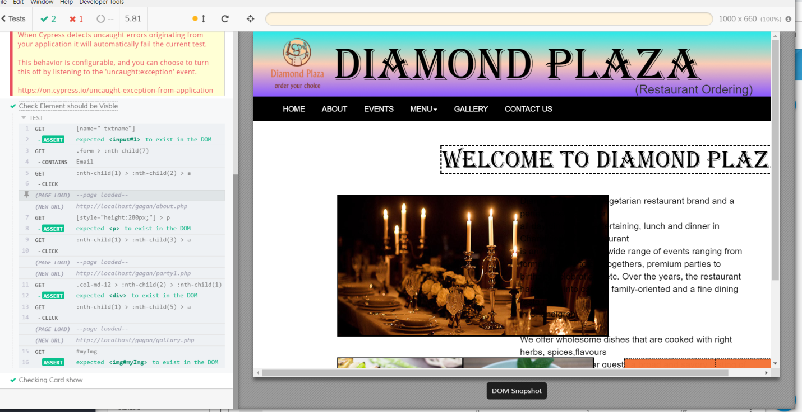

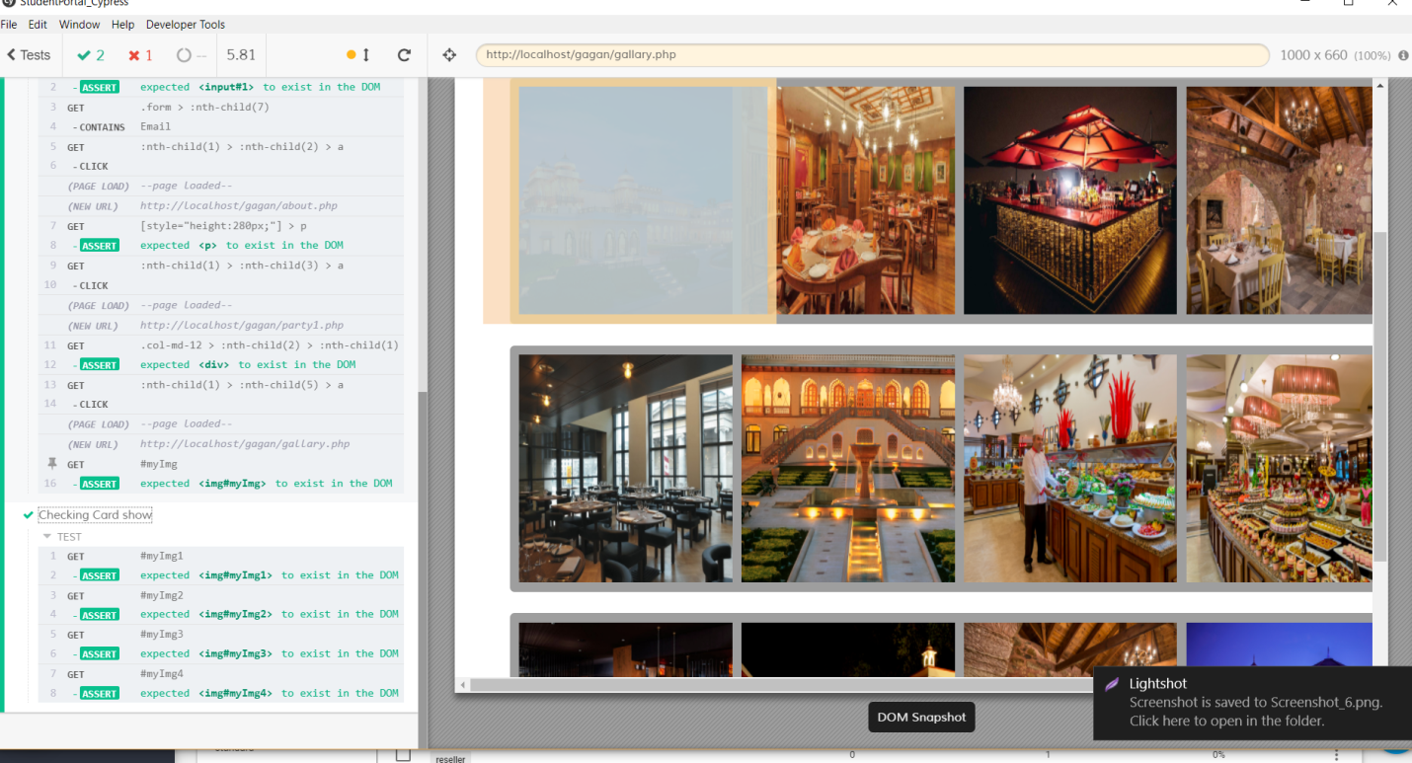

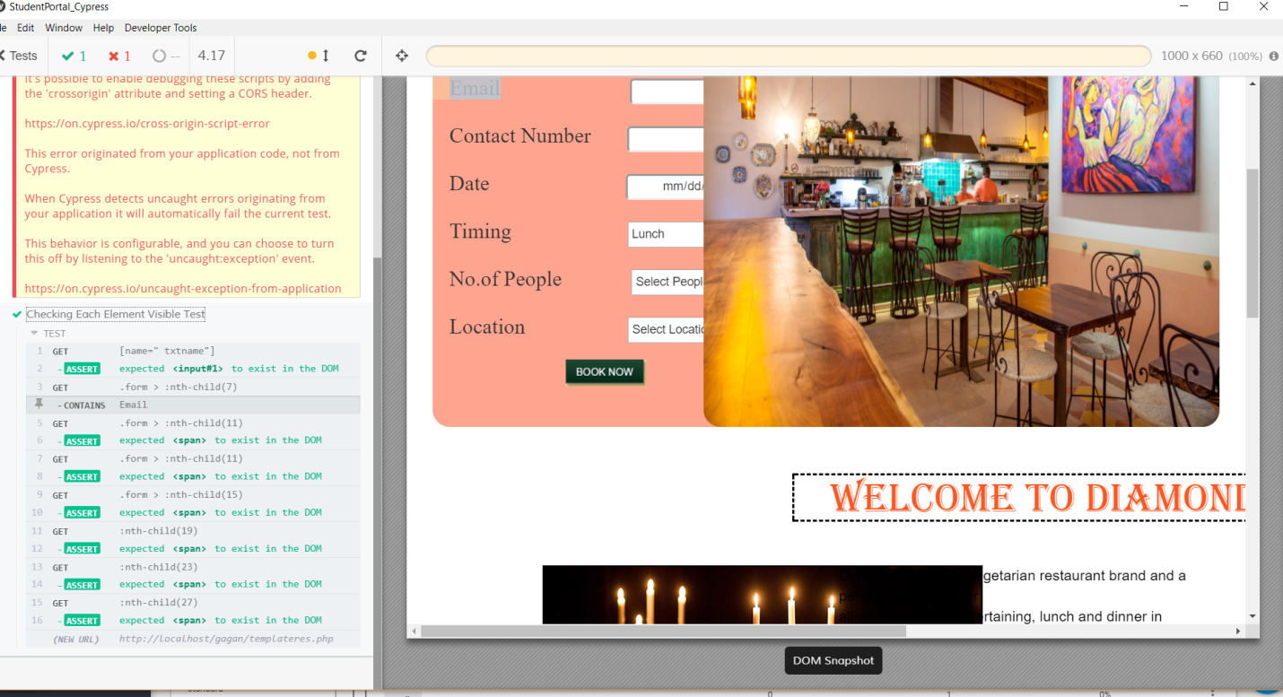

* **Conclusion**
* This website allows the users to browse through different product categories as well as save items to the cart and view detailed information about the order. Also users can add any number of items to the cart from any of the available food categories by simply clicking the Add to Cart button for each item.